

Rutherglen Agricultural Society Inc.

135th Annual Show

Sunday October 19th, 2025



Horse Schedule

Breeds ring, Open rings 1 and 2, Fun ring
Entry Fees:
$20 block Rings 1, 2, 3
$10 block Ring 4 (Fun ring)

Sashes for Champion and Reserve unless otherwise stated

All Horse Events Post Entry
Please enter at the Horse Office adjacent to Horse Arena
Waiver to be signed before competing
On call vet – Corowa Vet Clinic (02) 6033 1803/ 0456 600 713

For all horse enquiries please contact Horse Show Co-ordinator Sara Love on 0419 511 877

We Thank Emma’s Website (Emmas Show horses)
for publicising our Horse Program for the 2025 Rutherglen Show.
Horse Program Conditions of Entry

All competitors to sign an indemnity waiver prior to riding on the grounds
A.S. Approved safety helmets MUST be worn on the showgrounds by all competitors while mounted at all times as per standards association.

Please refer to the VAS Horse Exhibitor Handbook for further
Special Awards to be run at completion of qualifying events

Supreme Led Horse of the Show
All champions in Led sections Rings 1-3 are eligible to compete
Sponsored by Poachers Paradise Hotel, $100 prize money and sash

Ken Buscall Memorial Supreme Welsh Cob or Cob Type
Sponsored by the Buscall Family, $100 prize money and sash

Supreme Led Shetland Pony of the Show
Sponsored by Must Love Dogs B&B Rutherglen, $100 prize money and sash

Supreme Saddle Horse and Supreme Show Hunter
to be judged from Champion ridden exhibits in Rings 2 & 3

W.G. Francis Memorial Supreme Saddle Horse of the Show
Sponsored by RW Francis and Family, $100 prize money and sash

Supreme Show Hunter of the Show
Sponsored by Lilliput Ag Rutherglen, $100 prize money and sash

Information.

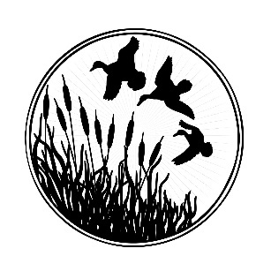


Rutherglen Agricultural Society would like to thank our generous Horse program sponsors:

Saddleworld Albury
Parkside Produce
RW Francis and Family

The Buscall Family
Poachers Paradise Hotel
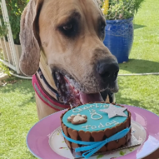
Must Love Dogs B & B Rutherglen
Colonial Clydesdales & Carriages

Lilliput Ag

Emma’s Website (Emma’s Show Horses)
VAS (Victorian Ag Shows)
Corowa Vet Clinic

Ring 1 - 8:30 am start
Class
- Rider under 8 years
- Rider 8 and under 10 years
- Rider 10 and under 12 years
Champion and Reserve Champion under 12 years

- Lead rein open pony
- Lead rein show hunter pony

- Rider 12 and under 14 years
- Rider 14 and under 16 years
- Rider 16 and under 18 years
Champion and Reserve Champion 12 and under 18 years

- Good hands riders 10 and under 15 years (must be using ordinary snaffle)

- Lady rider 18 years and under 25 years
- Lady rider 25 years and over
- Gentlemen rider 18 years and over
JD Payne Memorial Champion Senior Rider sponsored by Kay Lumby, $100 and sash

- Ridden Hack over 15hh and ne 15.2hh
- Ridden hack over 15.2hh and ne 16hh
- Open hack over 15hh and ne 16hh
- Lightweight hack over 15hh and ne 16hh
- Heavyweight hack over 15hh and ne 16hh
- Ladies hack over 15hh and ne 16hh
- Gentleman’s hack over 15hh and ne 16hh
Champion and Reserve Champion hack over 15hh and ne 16hh

- Ridden Hack over 16hh and ne 16.2hh
- Ridden Hack over 16.2hh
- Open hack over 16hh
- Lightweight hack over 16hh
- Heavyweight hack over 16hh

- Ladies Hack over 16hh
- Gentleman’s hack over 16hh
Champion and Reserve Champion hack over 16hh

‘Off the track’ Thoroughbred horse over 14.2hh Sponsored by VAS, sash and $50

- Ridden open OTT over 14.2hh
- Ridden Show Hunter OTT over 14.2hh

- Ridden ANSA ne 15hh
- Ridden ANSA over 15hh

Ring 1 continued
- Show hunter hack over 15hh and ne 15.2hh
- Show hunter hack over 15.2hh and ne 16hh
- Open show hunter hack over 15hh and ne 16hh
- Lightweight show hunter hack over 15hh and ne 16hh
- Heavyweight show hunter hack over 15hh and ne 16hh
- Ladies show hunter hack over 15hh and ne 16hh
- Gentleman’s show hunter hack over 15hh and ne 16hh
Champion and Reserve Champion Show hunter hack over 15hh and ne 16hh

- Show hunter hack over 16hh and ne 16.2hh
- Show hunter hack over 16.2hh
- Open show hunter hack over 16hh
- Lightweight show hunter hack over 16hh
- Heavyweight show hunter hack over 16hh
- Ladies show hunter hack over 16hh
- Gentleman’s show hunter hack over 16hh
Champion and Reserve Champion show hunter hack over 16hh

- Ridden open pony 11hh and under
- Ridden open pony over 11hh and ne 11.2hh
- Ridden open pony over 11.2hh and ne 12hh
- Ridden open pony over 12hh and ne 12.2hh
- Ridden open pony ne 12.2hh
- Ridden lightweight pony ne 12.2hh
- Ridden heavyweight ne 12.2hh
- Childs ridden pony ne 12.2hh
- Adults ridden pony ne 12.2hh
Champion and Reserve Champion Pony ne 12.2hh

- Ridden open pony over 12.2hh and ne 13hh
- Ridden open pony over 13hh and ne 13.2hh
- Ridden open pony over 13.2hh and ne 14hh
- Ridden open pony over 12.2 and ne 14hh
- Ridden lightweight pony over 12.2hh and ne 14hh
- Ridden heavyweight pony over 12.2hh and ne 14hh
- Childs ridden pony over 12.2hh and ne 14hh
- Adults ridden pony over 12.2hh and ne 14hh
Champion and Reserve Champion pony over 12.2hh and ne 14hh

- Ridden Show hunter pony 11hh and under
- Ridden Show hunter pony over 11hh and ne 11.2hh
- Ridden Show hunter pony over 11.2hh and ne 12hh
- Ridden Show hunter pony over 12hh and ne 12.2hh
- Ridden Show hunter pony ne 12.2hh
- Ridden Lightweight show hunter pony ne 12.2hh
- Ridden heavyweight show hunter pony ne 12.2hh
- Childs ridden show hunter pony ne 12.2hh
- Adults ridden show hunter pony ne 12.2hh
Champion and Reserve Champion show hunter pony ne 12.2hh
Ring 1 continued
- Ridden show hunter pony over 12.2hh and ne 13hh
- Ridden show hunter pony over 13hh and ne 13.2hh
- Ridden show hunter pony over 13.2hh and ne 14hh
- Ridden show hunter pony over 12.2hh and ne 14hh
- Ridden lightweight show hunter pony over 12.2hh and ne 14hh
- Ridden heavyweight show hunter pony over 12.2hh and ne 14hh
- Childs ridden show hunter pony over 12.2hh and ne 14hh
- Adults ridden show hunter pony over 12.2hh and ne 14hh
Champion and Reserve Champion show hunter pony over 12.2hh and ne 14hh

- Ridden open Galloway over 14hh and ne 14.2hh
- Ridden open Galloway over 14.2hh and ne 15hh
- Ridden open Galloway over 14hh and ne 15hh
- Ridden lightweight Galloway over 14hh and ne 15hh
- Ridden heavyweight Galloway over 14hh and ne 15hh
- Ladies ridden Galloway over 14hh and ne 15hh
- Gentleman’s ridden Galloway over 14hh and ne 15hh
Champion and Reserve Champion Galloway over 14hh and ne 15hh

- Ridden show hunter Galloway over 14hh and ne 14.2hh
- Ridden show hunter Galloway over 14.2hh and ne 15hh
- Ridden open show hunter Galloway over 14hh and ne 15hh
- Ridden lightweight show hunter Galloway over 14hh and ne 15hh
- Ridden heavyweight show hunter Galloway over 14hh and ne 15hh
- Ladies ridden Galloway over 14hh and ne 15hh
- Gentleman’s ridden Galloway over 14hh and ne 15hh
Champion and Reserve Champion Show hunter Galloway over 14hh and ne 15hh

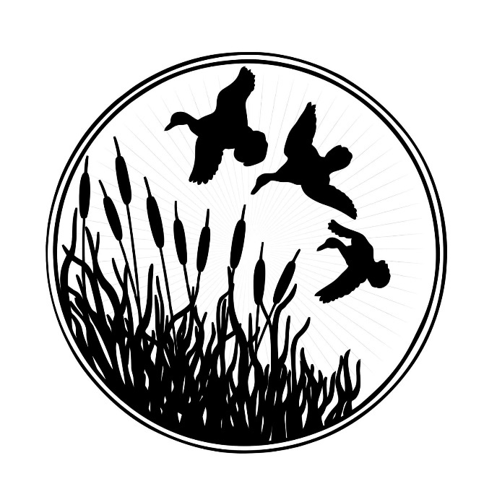

Ring 2 - 8:30 am start
ALL LED CHAMPIONS FROM THIS RING ALSO ELIGIBLE TO COMPETE FOR SUPREME LED EXHIBIT OF SHOW - and we encourage all Champions to stay for this event.

Class
- Led open hack over 15hh and ne 16hh
- Led open hack over 16hh
- Led Show hunter hack over 15hh and ne 16hh
- Led Show hunter hack over 16hh
Champion and Reserve Champion Led Hack

- Led ANSA ne 15hh
- Led ANSA over 15hh


‘Off the track’ Thoroughbred horse over 14.2hh
- Led open OTT over 14.2hh
- Led Show Hunter OTT over 14.2hh

- Led open Galloway over 14hh and ne 14.2hh
- Led open Galloway over 14.2hh and ne 15hh
- Led show hunter Galloway over 14hh and ne 14.2hh
- Led show hunter Galloway over 14.2hh and ne 15hh
Champion and Reserve Champion Lad Galloway

- Led open pony 12.2hh and under
- Led open pony over 12.2hh and ne 14hh
- Led show hunter pony 12.2hh and under
- Led show hunter pony over 12.2hh and ne 14hh
Champion and Reserve Champion Led pony

- Ridden open Galloway over 14hh and ne 14.2hh
- Ridden open Galloway over 14.2hh and ne 15hh
- Ridden open Galloway over 14hh and ne 15hh
- Ridden lightweight Galloway over 14hh and ne 15hh
- Ridden heavyweight Galloway over 14hh and ne 15hh
- Ladies ridden Galloway over 14hh and ne 15hh
- Gentleman’s ridden Galloway over 14hh and ne 15hh
Champion and Reserve Champion Galloway over 14hh and ne 15hh

- Ridden show hunter Galloway over 14hh and ne 14.2hh
- Ridden show hunter Galloway over 14.2hh and ne 15hh
- Ridden open show hunter Galloway over 14hh and ne 15hh
- Ridden lightweight show hunter Galloway over 14hh and ne 15hh
- Ridden heavyweight show hunter Galloway over 14hh and ne 15hh
- Ladies ridden Galloway over 14hh and ne 15hh
- Gentleman’s ridden Galloway over 14hh and ne 15hh
Champion and Reserve Champion Show hunter Galloway over 14hh and ne 15hh

- Ridden Hack over 15hh and ne 15.2hh
- Ridden hack over 15.2hh and ne 16hh
- Open hack over 15hh and ne 16hh
- Lightweight hack over 15hh and ne 16hh
- Heavyweight hack over 15hh and ne 16hh
Ring 2 continued

- Lady’s hack over 15hh and ne 16hh
- Gentleman’s hack over 15hh and ne 16hh
Champion and Reserve Champion hack over 15hh and ne 16hh

- Ridden Hack over 16hh and ne 16.2hh
- Ridden Hack over 16.2hh
- Open hack over 16hh
- Lightweight hack over 16hh
- Heavyweight hack over 16hh
- Ladies Hack over 16hh
- Gentleman’s hack over 16hh
Champion and Reserve Champion hack over 16hh

- Show hunter hack over 15hh and ne 15.2hh
- Show hunter hack over 15.2hh and ne 16hh
- Open show hunter hack over 15hh nd ne 16hh
- Lightweight show hunter hack over 15hh and ne 16hh
- Heavyweight show hunter hack over 15hh and ne 16hh
- Ladies show hunter hack over 15hh and ne 16hh
- Gentleman’s show hunter hack over 15hh and ne 16hh
Champion and Reserve Champion Show hunter hack over 15hh and ne 16hh

- Show hunter hack over 16hh and ne 16.2hh
- Show hunter hack over 16.2hh
- Open show hunter hack over 16hh
- Lightweight show hunter hack over 16hh
- Heavyweight show hunter hack over 16hh
- Ladies show hunter hack over 16hh
- Gentleman’s show hunter hack over 16hh
Champion and Reserve Champion show hunter hack over 16hh

- Ridden open pony 11hh and under
- Ridden open pony over 11hh and ne 11.2hh
- Ridden open pony over 11.2hh and ne 12hh
- Ridden open pony over 12hh and ne 12.2hh
- Ridden open pony ne 12.2hh
- Ridden lightweight pony ne 12.2hh
- Ridden heavyweight ne 12.2hh
- Childs ridden pony ne 12.2hh
- Adults ridden pony ne 12.2hh
Champion and Reserve Champion Pony ne 12.2hh

Ring 2 continued
- Ridden open pony over 12.2hh and ne 13hh
- Ridden open pony over 13hh and ne 13.2hh
- Ridden open pony over 13.2hh and ne 14hh
- Ridden open pony over 12.2 and ne 14hh
- Ridden lightweight pony over 12.2hh and ne 14hh
- Ridden heavyweight pony over 12.2hh and ne 14hh
- Childs ridden pony over 12.2hh and ne 14hh
- Adults ridden pony over 12.2hh and ne 14hh
Champion and Reserve Champion pony over 12.2hh and ne 14hh

- Ridden Show hunter pony 11hh and under
- Ridden Show hunter pony over 11hh and ne 11.2hh
- Ridden Show hunter pony over 11.2hh and ne 12hh
- Ridden Show hunter pony over 12hh and ne 12.2hh
- Ridden Show hunter pony ne 12.2hh
- Ridden Lightweight show hunter pony ne 12.2hh
- Ridden heavyweight show hunter pony ne 12.2hh
- Childs ridden show hunter pony ne 12.2hh
- Adults ridden show hunter pony ne 12.2hh
Champion and Reserve Champion show hunter pony ne 12.2hh

- Ridden show hunter pony over 12.2hh and ne 13hh
- Ridden show hunter pony over 13hh and ne 13.2hh
- Ridden show hunter pony over 13.2hh and ne 14hh
- Ridden show hunter pony over 12.2hh and ne 14hh
- Ridden lightweight show hunter pony over 12.2hh and ne 14hh
- Ridden heavyweight show hunter pony over 12.2hh and ne 14hh
- Childs ridden show hunter pony over 12.2hh and ne 14hh
- Adults ridden show hunter pony over 12.2hh and ne 14hh
Champion and Reserve Champion show hunter pony over 12.2hh and ne 14hh



On- Call vet – Corowa Vet Clinic
0456 600 713

Ring 3 - 8:30 am start
ALL LED CHAMPIONS FROM THIS RING ALSO ELIGIBLE TO COMPETE FOR SUPREME LED EXHIBIT OF SHOW - and we encourage all Champions to stay for this event.

Ponies to be 87cms or under
- Miniature pony stallion or colt
- Miniature pony gelding
- Miniature pony mare or filly
Champion and Reserve Champion Miniature pony

Shetlands ne 8.2hh
- Shetland pony stallion or colt ne 8.2hh
- Shetland pony gelding ne 8.2hh
- Shetland pony mare or filly ne 8.2hh
Champion and Reserve Champion Shetland pony ne 8.2hh

Shetlands over 8.2hh and ne 10.2hh
- Shetland pony stallion or colt over 8.2hh and ne 10.2hh
- Shetland pony gelding over 8.2hh and ne 10.2hh
- Shetland pony mare or filly over 8.2hh and ne 10.2hh
Champion and Reserve Champion Shetland over 8.2hh and ne 10.2hh

Supreme Led Shetland Pony of Show
Sponsored by Must Love Dogs B&B Rutherglen, $100 prize money and sash
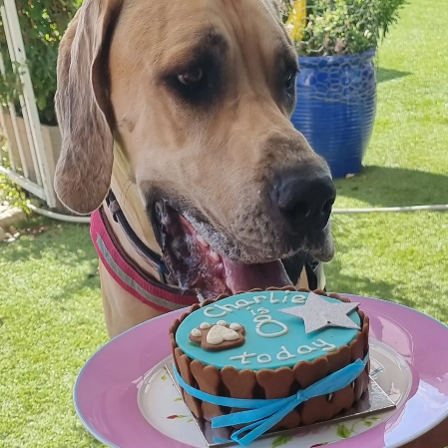
Welsh Mountains Ponies - Section A
- Stallion or colt
- Mare
- Filly 3 yrs and under
Champion and Reserve Champion Welsh A

Welsh Mountains Ponies – Section B
- Stallion or colt
- Mare
- Filly 3 yrs and under
Champion and Reserve Champion Welsh B
Must Love Dogs
Bed and Breakfast Rutherglen

Welsh Mountains Ponies – Section C
- Stallion or colt
- Mare
- Filly 3 yrs and under
Champion and Reserve Champion Welsh C

Welsh Mountains Ponies – Section D
- Stallion or colt
- Mare
- Filly 3 yrs and under
Champion and Reserve Champion Welsh D

Ken Buscall Memorial Supreme Welsh Cob or Cob type
Sash and $100 prize money, sponsored by the Buscall Family

Ring 3 continued

Welsh Geldings
- Gelding of section A breeding
- Gelding of section B breeding
- Gelding of section C or D breeding
Champion and Reserve Champion Welsh Geldings

- Part Welsh young stock 3 yrs and under
- Part Welsh 12.2hh and under
- Part Welsh 12.2hh and ne 13.2hh
- Part Welsh 13.2hh and over
Champion and Reserve Champion part bred Welsh

Ridden Shetlands
- Stallion or Colt
- Gelding
- Mare or filly
Champion and Reserve Champion ridden Shetlands

Australian Saddle Pony
- Led male
- Led female
Champion and Reserve Champion Led Australian Saddle Pony

Riding Ponies
- Led male
- Led female
Champion and Reserve Champion Led Riding Pony

Arabian Derivative
- Led male
- Led female
Champion and Reserve Champion Arabian Derivative

Led Purebred APSB (Connemaras, New Forest, Highland, Australia, Shetland)
- Led purebred mare or filly under 14hh
- Led purebred male under 14hh
Champion and Reserve Champion Led Purebred APSB

Led Partbred APSB
- Led female
- Led male
Champion and Reserve Champion Led Partbred APSB

Coloured Classes
- Led colt, filly or gelding 3 yrs and under
- Led mare over 3 yrs
- Led gelding over 3 yrs
Champion and Reserve Champion Coloured Classes

Ring 3 continued

Ridden Riding Pony
- Male under 14.2hh
- Female under 14.2hh
Champion and Reserve Champion Ridden Riding Pony

Ridden Saddle Pony
- Male
- Female
Champion and Reserve Champion Ridden Saddle Pony

Ridden Arabian Derivatives
- Male
- Female
Champion and Reserve Champion Ridden Arabian Derivatives

Ridden Welsh
- Section A,B,C or D Mare
- Section A,B,C or D Gelding
- Section A,B,C or D Stallion
Champion and Reserve Champion Ridden Welsh

Ridden Part Welsh
- Ridden ne 12.2hh
- Ridden over 12.2hh and ne 13.2hh
- Ridden over 13.2hh
Champion and Reserve Champion Ridden Part Welsh

Ridden Purebred APSB
- Ridden Gelding
- Ridden Mare
Champion and Reserve Champion Ridden Purebred APSB

Ridden Part bred APSB
- Ridden Gelding
- Ridden Mare
Champion and Reserve Champion Ridden Part bred APSB

Ridden Coloured
- Ridden male
- Ridden female
Champion and Reserve Champion Ridden Coloured

Standard Breds
- Led male
- Led female
Champion and Reserve Champion Standard Breds

Ring 3 continued

Heavy Horses
- Led heavy horse male
- Led heavy horse mare or filly

Mrs JD Payne Memorial Champion and Reserve Champion Heavy Horse
Sponsored by Colonial Clydesdales & Carriages

Standard Breds Ridden
- Ridden male
- Ridden female
Champion and Reserve Champion Ridden Standard Bred

VAS Alabar Hero series qualifier
Sponsored by VAS, sash and $50


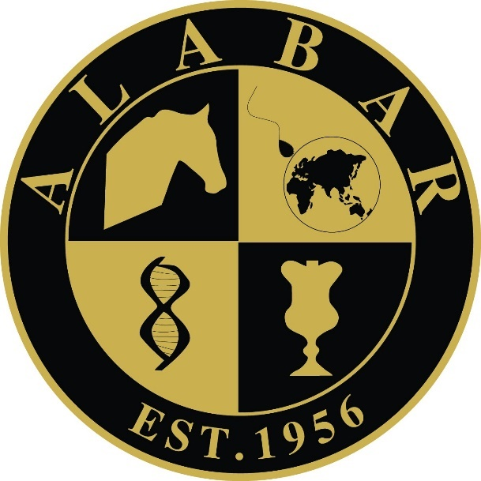

Ring 4 – Fun ring

This is a fun ring for novice ponies and riders 15 years and under who are not competing in the open sections of the horse program. Fun ring program subject to change on the day pending entries.

May be led
Approved safety helmets and footwear must be worn in all classes

- Best presented
- Best black pony
- Best grey pony
- Best chestnut pony
- Best bay pony
- Best coloured pony
- Apple bobbing
- Best fancy dress
- Sack race
- Handy mount

- Activity mount

